URL: <http://www.aestheticdental.com.sg>

Aesthetic Dental is a modern and friendly dental office situated in the heart of Singapore's Central Business District. We seek to be informative and offer you the most current forms of dentistry available at an affordable price.Furthermore, we practice in a clean and safe treatment environment with sterilized instruments to ensure our patients receive the highest standard of hygiene. For the detection of dental decay we are now able to use harmless laser instruments, such as the Diagnodent to identity decayed teeth quickly and painlessly. And following the removal of decay, dental fillings can now be selected in natural tooth shades using life-like dental composite resins or porcelain to make them blend imperceptibly with the surrounding teeth.

**Services:**

Porcelain Crowns, Veneers and Inlays in one visit 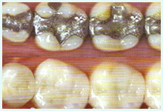Experience the new CEREC CAD/CAM technology where beautiful crowns, veneers and inlays can be completed in one visit.

Orthodontics (Braces) 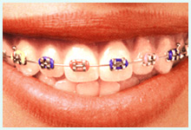The advent of transparent brackets helps to improve aesthetics during braces treatment. Brackets can also be placed at the back of teeth so that they are not in view.

Dental Implants 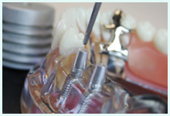The advantages of  implant-supported teeth are increased biting forces compared to removable dentures or conventional fixed bridges. There is also no neeed to shave or trim down adjacent teeth when an implant is chosen over conventional bridge options. This preserves your own sound teeth.   http://www.aestheticdental.com.sg/images/share/spacer.gifTeeth Whitening 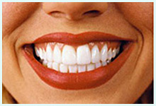In-office teeth whitening and take-home teeth whitening kits are available in our clinic to help you to achieve a dazzling smile.

Oral Surgery 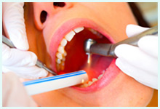Medisave funds can now be used for various surgical procedures such as wisdom tooth removal, implants, and tongue-tie.

We offer the following products  
& services:

* Detailed Examination and Consultation with use of Intra-oral Camera
* Dental Radiographic Examination Plus Digital X-Rays for Reduced Radiation
* Children's Dentistry & Laser Diagnosis of decays
* Careful cleansing of teeth including airflow polishing
* Aesthetic Tooth-Coloured Fillings (Mercury-free) • Crowns and Bridges (including metal-free crowns)
* Porcelain Veneers / Inlays / Crowns in One Visit
* Dental Implants to replace lost teeth
* Fixed & Removal Dentures
* Orthodontics ("Braces treatment") including "invisible braces"
* Tooth Whitening (Bleaching)
* Splint Therapy (TMJ treatment)
* Laser Treatment for soft tissues e.g tongue-tie & small growths
* Wisdom Tooth Removal

**Photos**

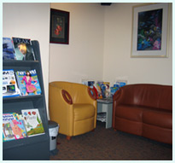 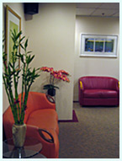 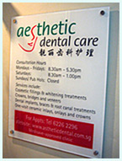

**Doctors:**

Dr Tang Kok Weng  
Dr Quek Li Wei  
Dr Sharon L S Leng  
Dr Tengku Sinannage  
Dr Anthony Goh

**Contact us:**

133 Cecil street#04-01 keck seng tower

Singapore 069535

Telephone: 65-6226-2296

Fax: 65-6221-9087